**UNIT 3**

**Level 1**

**HTML Tables**

1. Create a web page to display table with 3 rows and 3 columns.
2. Create a web page to display table with 2 rows and 3 columns with border thickness as 10 and colour as green.
3. Create a webpage to display table with 3 rows and 2 columns with table header row and table background colour as grey.
4. Create a webpage to display table with 3 rows and 3 columns with cell spacing and cell padding attributes.
5. Create a web page to display the table as follows

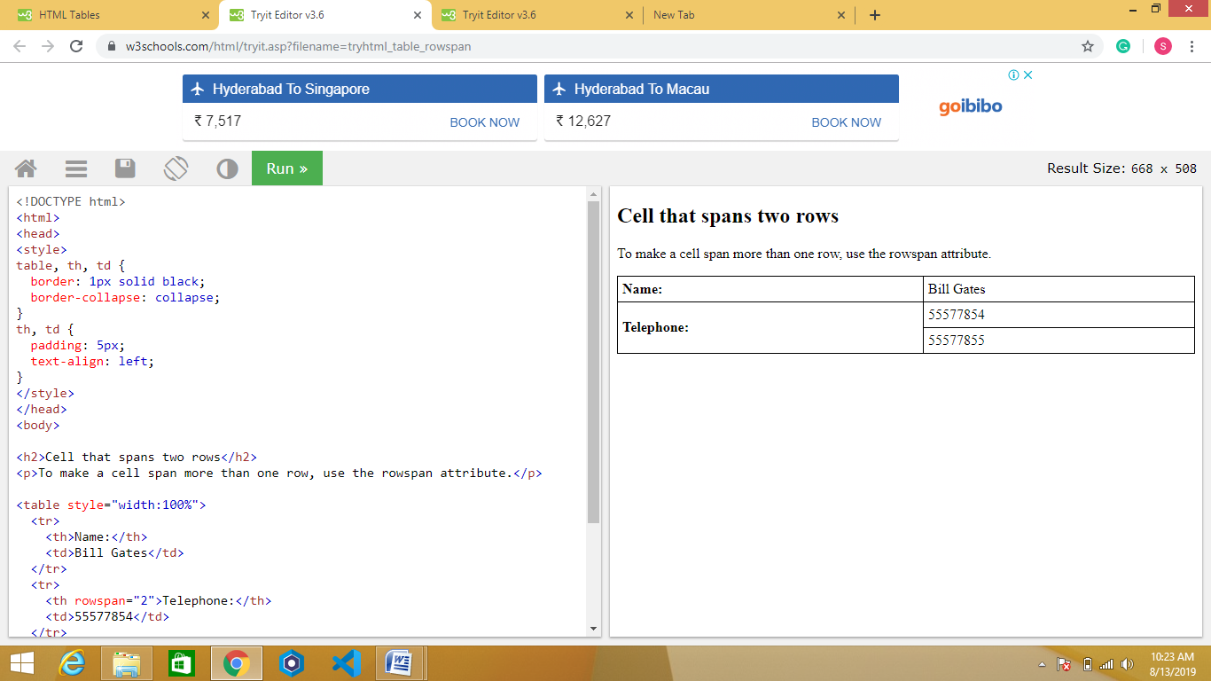

1. Create a webpage to display the table with caption as follows

